**My SQL Task**

**Create the ecommerce database**

-- Create the database

CREATE DATABASE ecommerce;

-- Use the created database

USE ecommerce;

**Output:**

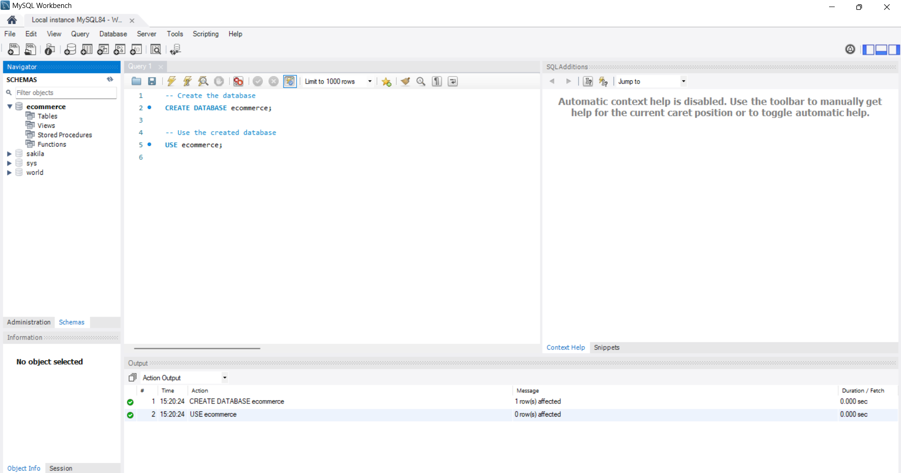

**Create the customers, orders, and products tables**

-- Create the 'customers' table

CREATE TABLE customers (

id INT AUTO_INCREMENT PRIMARY KEY,

name VARCHAR(100) NOT NULL,

email VARCHAR(100) UNIQUE NOT NULL,

address VARCHAR(255) NOT NULL

);

-- Create the 'orders' table

CREATE TABLE orders (

id INT AUTO_INCREMENT PRIMARY KEY,

customer_id INT,

order_date DATE NOT NULL,

total_amount DECIMAL(10, 2) NOT NULL,

FOREIGN KEY (customer_id) REFERENCES customers(id)

);

-- Create the 'products' table

CREATE TABLE products (

id INT AUTO_INCREMENT PRIMARY KEY,

name VARCHAR(100) NOT NULL,

price DECIMAL(10, 2) NOT NULL,

description TEXT

);

**Output:**

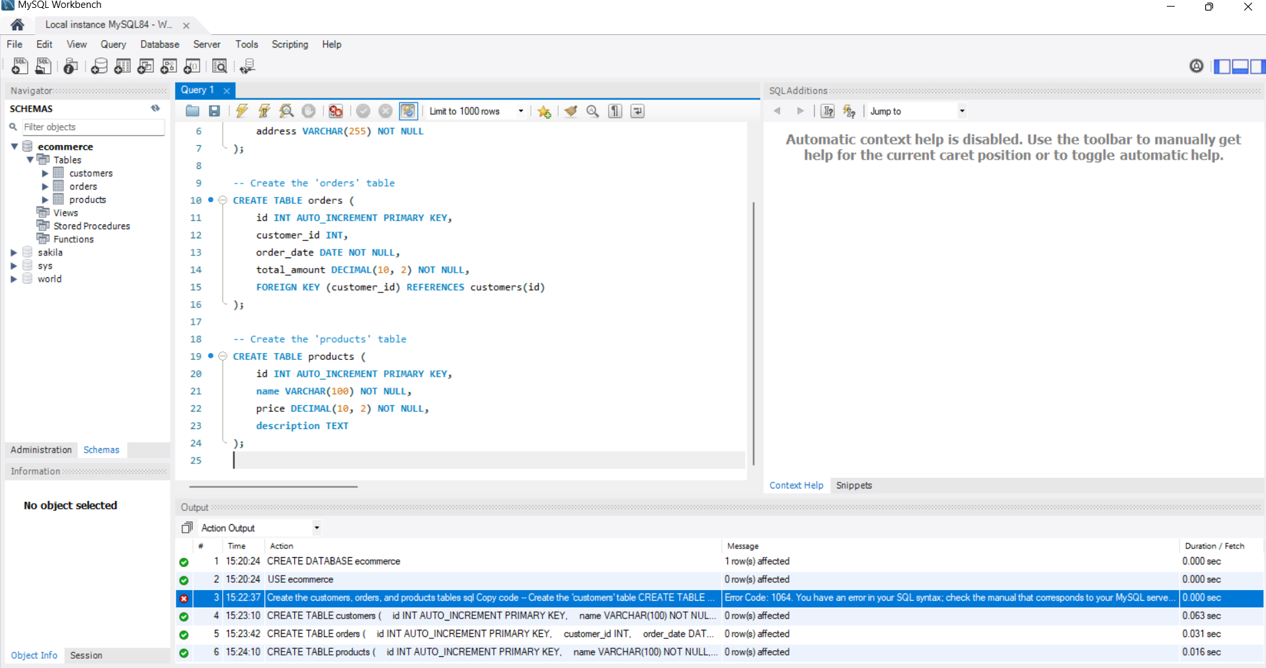

**Insert Sample Data into the Tables**

-- Insert sample data into the 'customers' table

INSERT INTO customers (name, email, address) VALUES

('Alice Johnson', 'alice@example.com', '123 Maple St'),

('Bob Smith', 'bob@example.com', '456 Oak Ave'),

('Charlie Brown', 'charlie@example.com', '789 Pine Rd');

-- Insert sample data into the 'orders' table

INSERT INTO orders (customer_id, order_date, total_amount) VALUES

(1, '2024-10-15', 120.50),

(2, '2024-10-16', 200.00),

(3, '2024-10-10', 75.30);

-- Insert sample data into the 'products' table

INSERT INTO products (name, price, description) VALUES

('Product A', 25.00, 'Description for Product A'),

('Product B', 35.00, 'Description for Product B'),

('Product C', 40.00, 'Description for Product C');

**Output:**

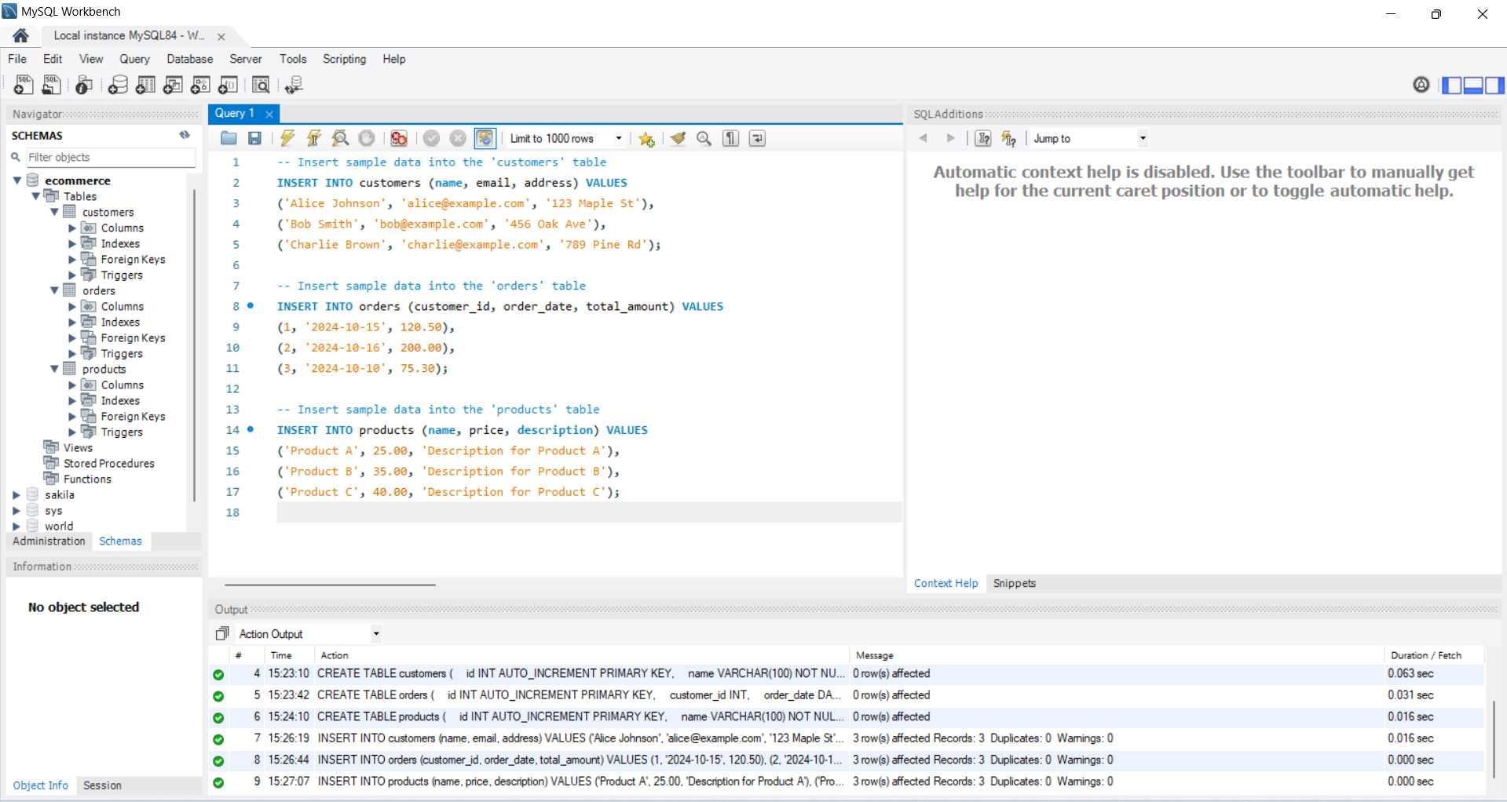

**Queries**

**Retrieve all customers who have placed an order in the last 30 days**

-- Retrieve customers who placed an order in the last 30 days

SELECT DISTINCT c.name, c.email

FROM customers c

JOIN orders o ON c.id = o.customer_id

WHERE o.order_date >= CURDATE() - INTERVAL 30 DAY;

**Output:**

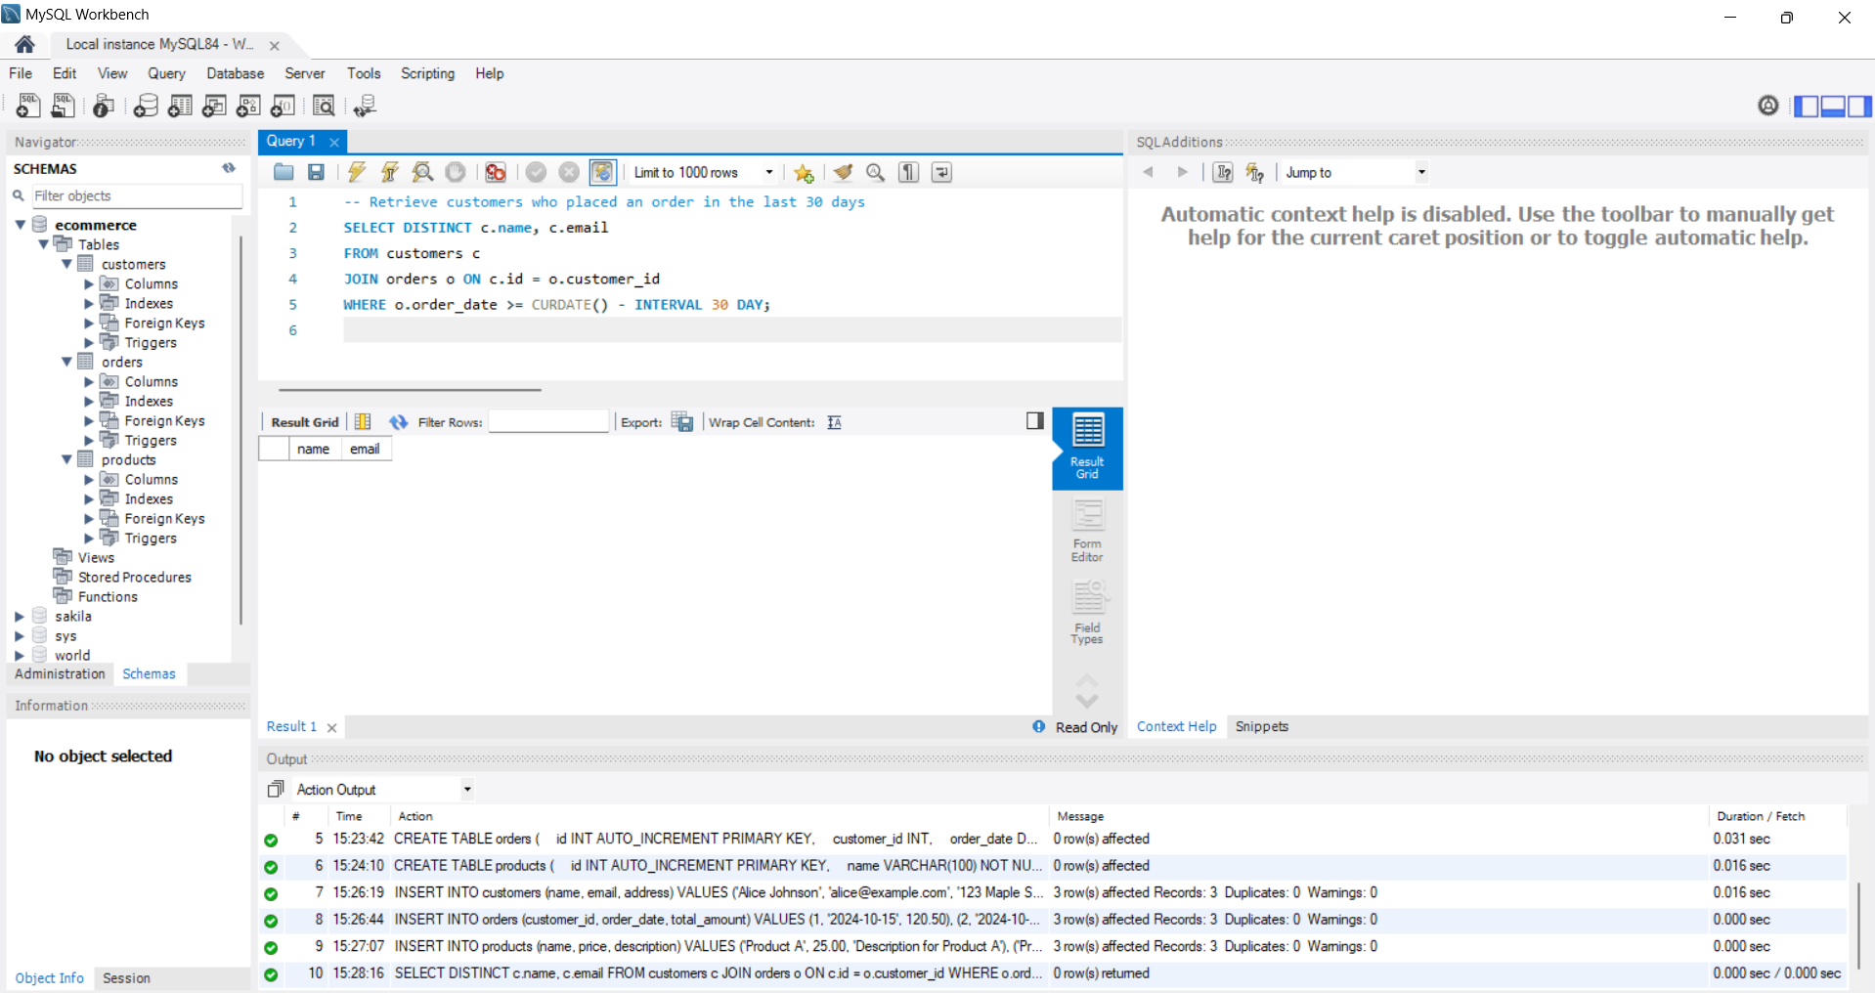

**Get the total amount of all orders placed by each customer**

-- Get total amount of orders placed by each customer

SELECT c.name, SUM(o.total_amount) AS total_spent

FROM customers c

JOIN orders o ON c.id = o.customer_id

GROUP BY c.id;

**Output:**

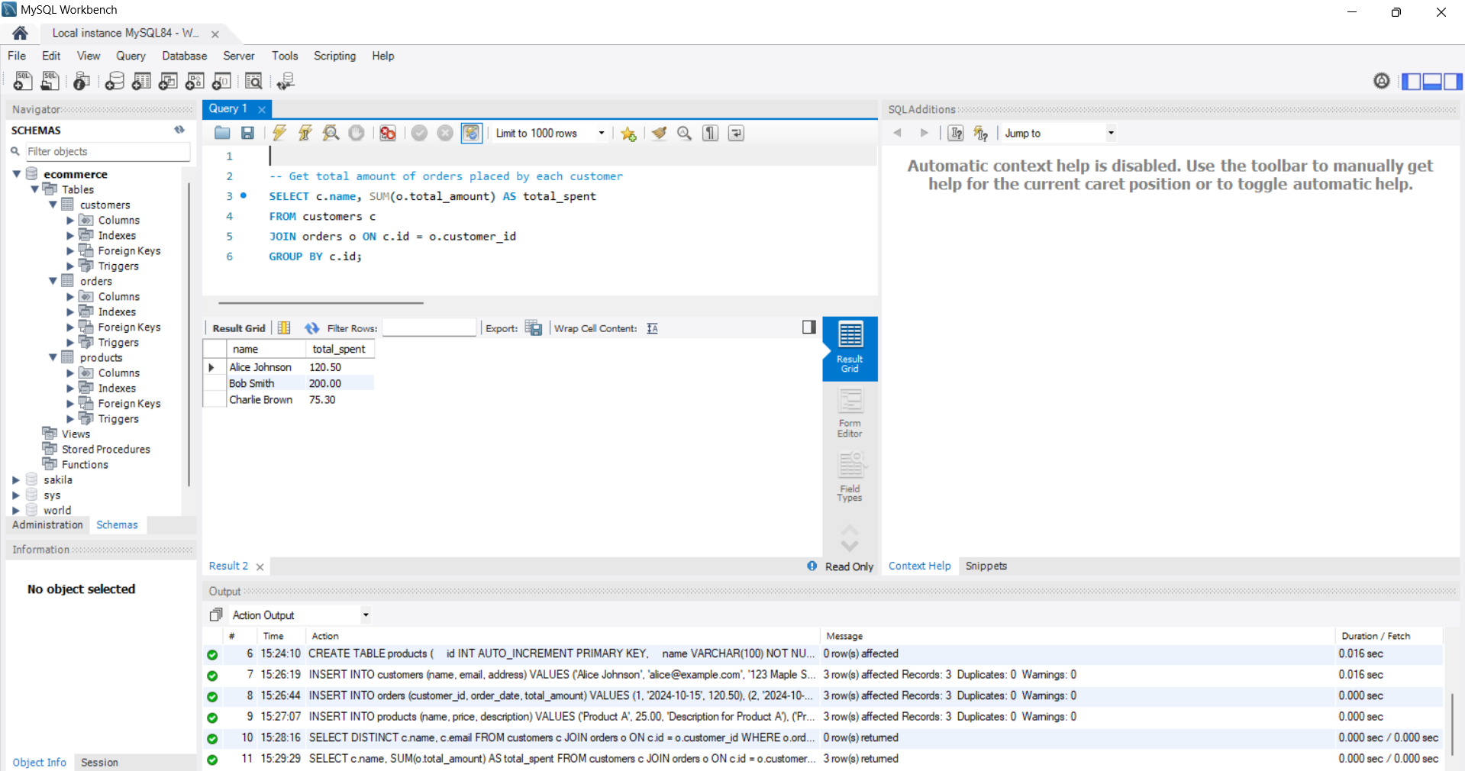

**Update the price of Product C to 45.00**

-- Update the price of Product C to 45.00

UPDATE products

SET price = 45.00

WHERE name = 'Product C';

**Output:**

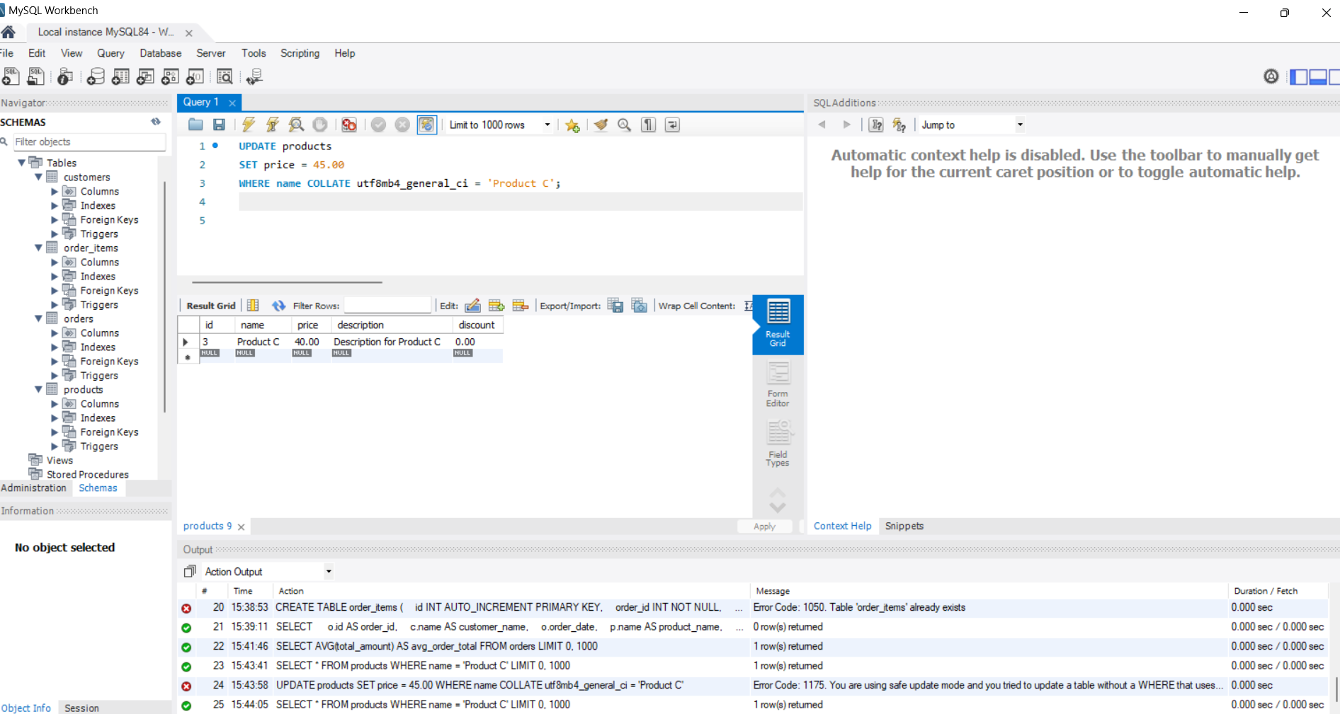

**Add a new column 'discount' to the products table**

-- Add a 'discount' column to the 'products' table

ALTER TABLE products

ADD COLUMN discount DECIMAL(5, 2) DEFAULT 0.00;

**Output:**

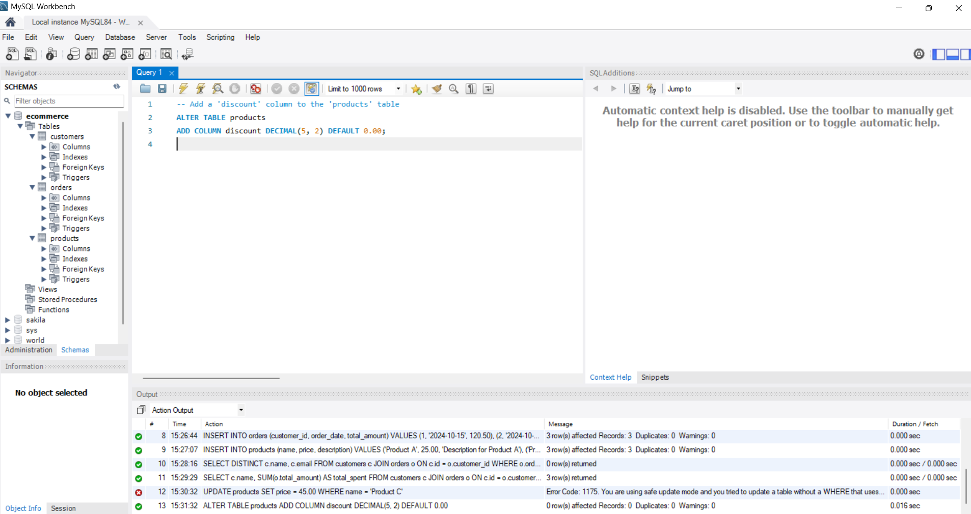

**Retrieve the top 3 products with the highest price**

-- Retrieve top 3 products with the highest price

SELECT name, price

FROM products

ORDER BY price DESC

LIMIT 3;

**Output:**

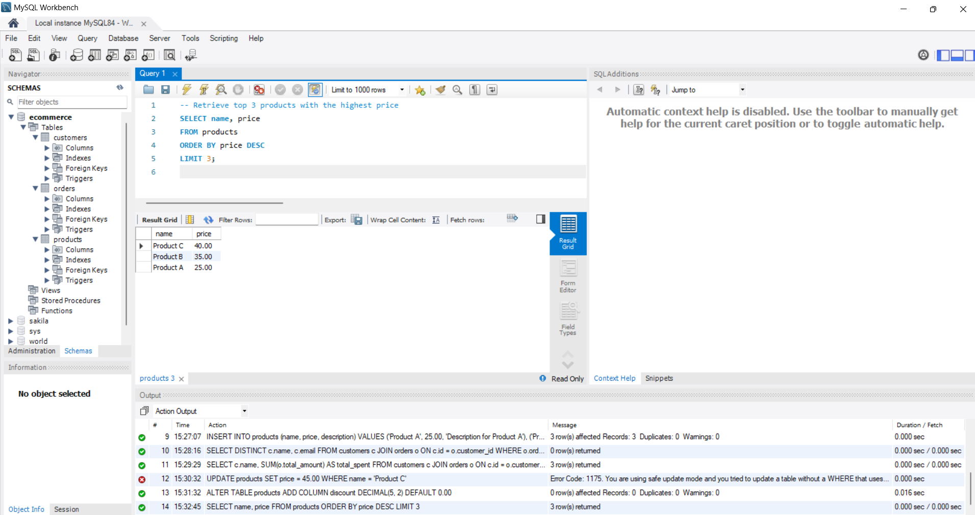

**Join the orders and customers tables to retrieve the customer's name and order date for each order**

-- Join 'orders' and 'customers' to get customer's name and order date

SELECT c.name AS customer_name, o.order_date

FROM orders o

JOIN customers c ON o.customer_id = c.id;

**Output:**

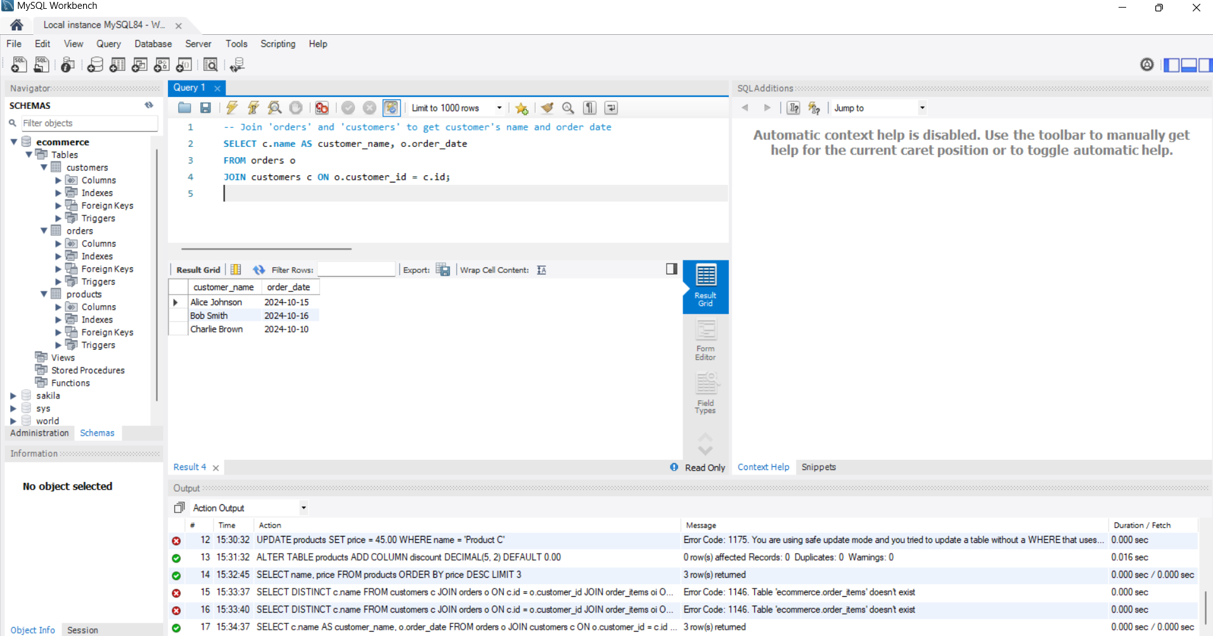

**Retrieve the orders with a total amount greater than 150.00**

-- Retrieve orders with a total amount greater than 150.00

SELECT o.id, o.order_date, o.total_amount

FROM orders o

WHERE o.total_amount > 150.00;

**Output:**

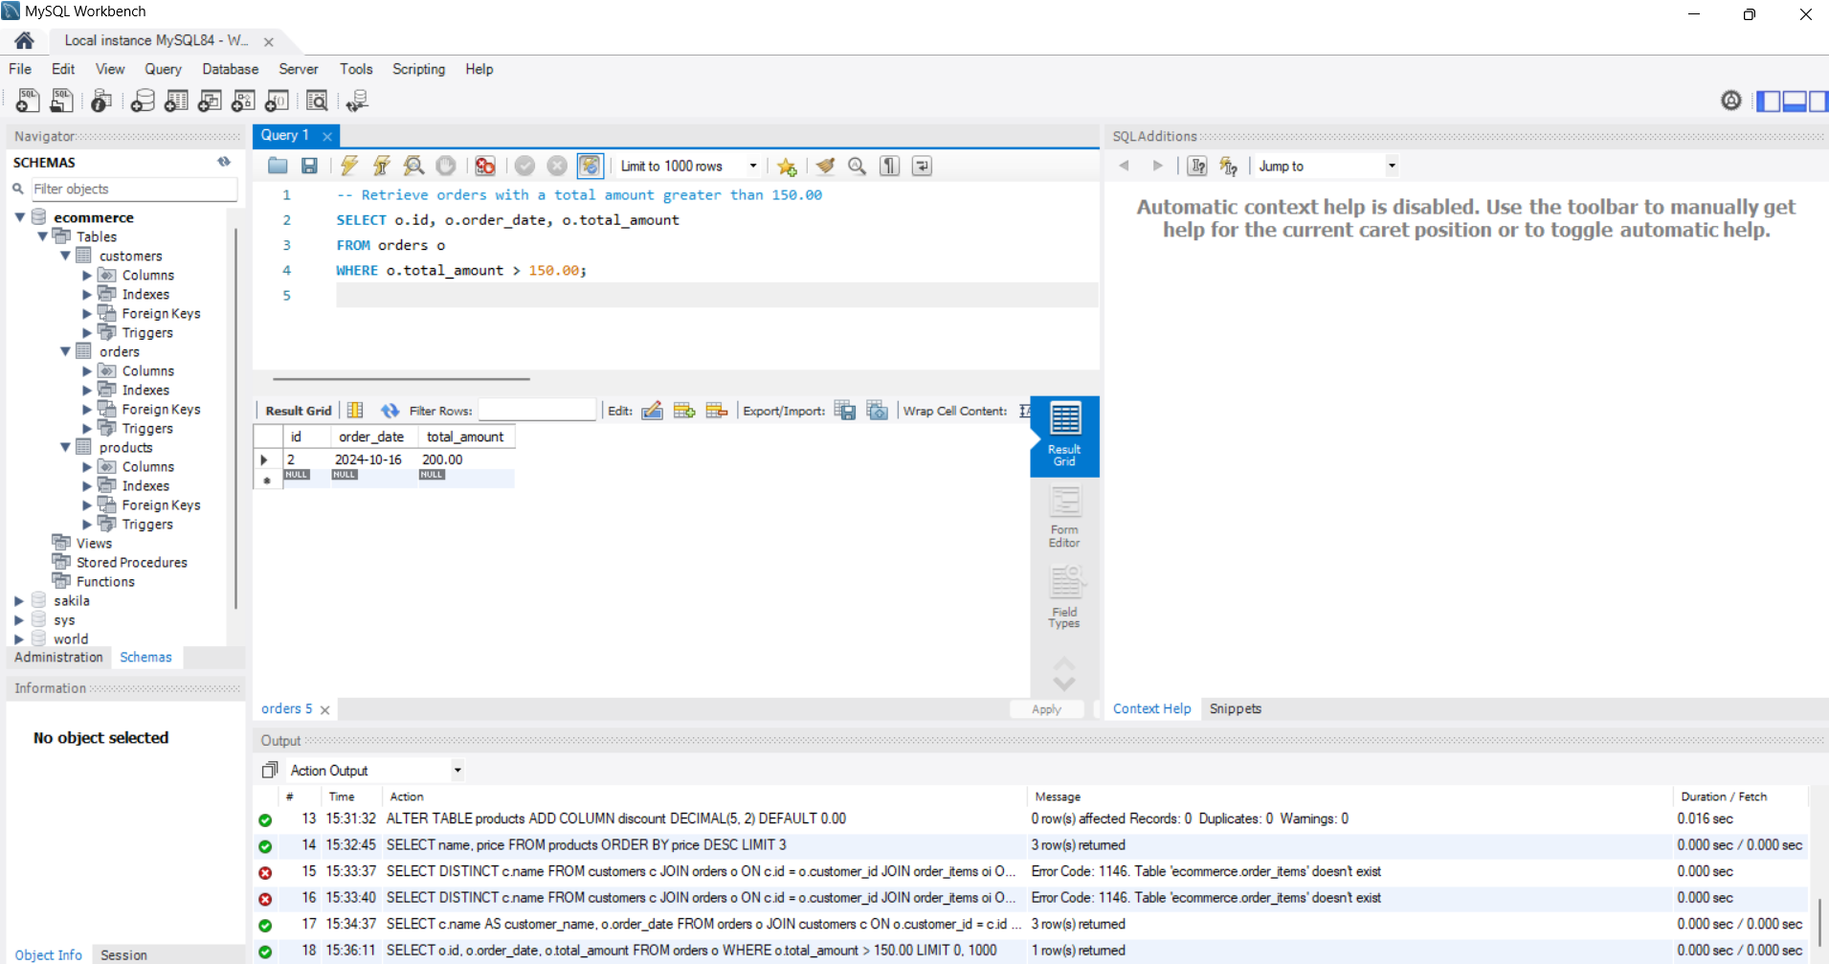

**Normalize the database by creating a separate table for order items and updating the orders table**

-- Create the 'order_items' table to normalize the database

CREATE TABLE order_items (

id INT AUTO_INCREMENT PRIMARY KEY,

order_id INT,

product_id INT,

quantity INT,

FOREIGN KEY (order_id) REFERENCES orders(id),

FOREIGN KEY (product_id) REFERENCES products(id)

);

**Output:**

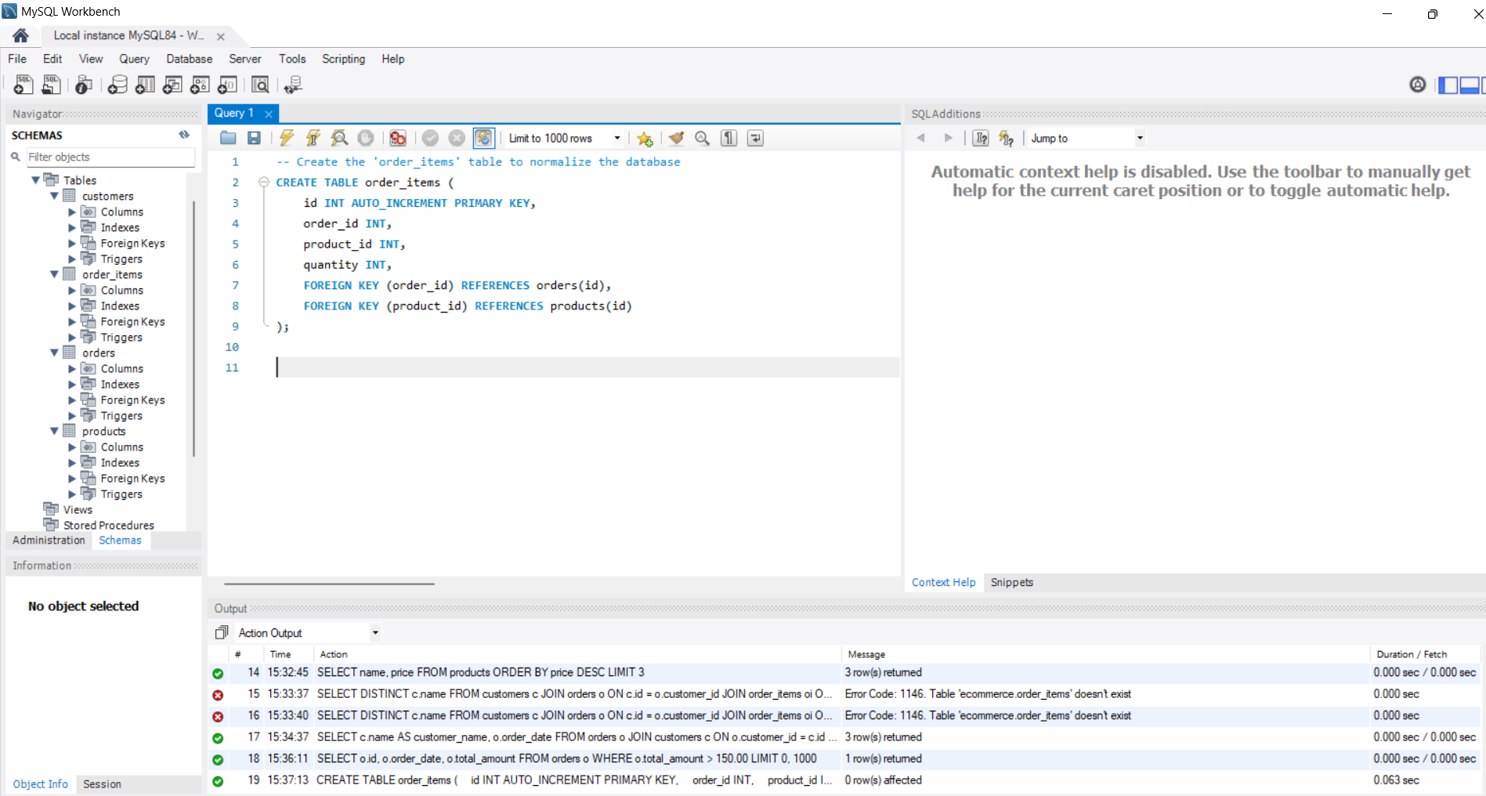

**Query to Join All Related Tables (Example)**

Retrieve full details for each order, including customer name, order date, product name, and quantity:

SELECT

o.id AS order_id,

c.name AS customer_name,

o.order_date,

p.name AS product_name,

oi.quantity,

p.price AS product_price,

(oi.quantity * p.price) AS line_total

FROM orders o

JOIN customers c ON o.customer_id = c.id

JOIN order_items oi ON o.id = oi.order_id

JOIN products p ON oi.product_id = p.id;

**Output:**

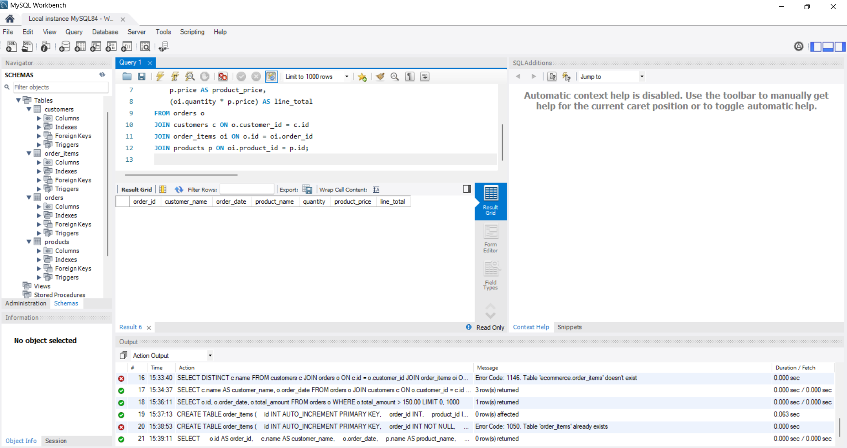

**Retrieve the average total of all orders**

-- Retrieve the average total of all orders

SELECT AVG(total_amount) AS avg_order_total

FROM orders;

**Output:**

